Interfacing The Xbow Mica2 mote to the Khepera Robot

Introducing the UART data exchange link
Both, the Khepera miniature robot and the Mica2 mote are capable of transmitting and receiving serial data over the corresponding lines. It appeared as the most suitable way of linking the two devices together. One additional great advantage is that both devices can be programmed in an interrupt-oriented manner, providing a flexible way of building applications. Finally, in the simplest case, the mote may provide us with a reliable radio communication link to another device which may be yet another mote, or a stationary PC.

Hardware Specifications
Mica2
The mica2 mote Rx, Tx and Gnd lines are conveyed through the board connections to a DF-9 connector, commonly used to attach the sensor board:

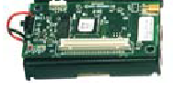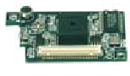
The DF-9 male connector
on the mica2 board
The DF-9 male connector
on the sensor board
DF-9 connector on Mica2 mote

Khepera
The Khepera robot provides us with a number of pin-connections (destined to potentially accommodate an extension turret of some sort) on its top side. Pins 53 and 54 provide us with the corresponding Tx and Rx signals. Gnd and +5V lie on pins 3 and 4 respectively:

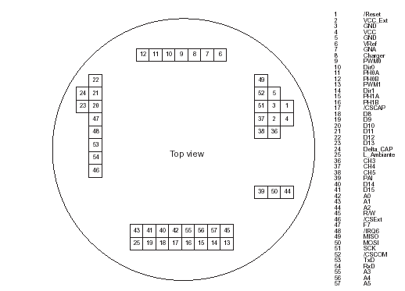
Khepera Top View (Pinout)

Problem Analysis
In order to convey signals from one device to the other, several hardware incompatibilities arise: The Khepera utilizes TTL/CMOS voltage levels that provide us with serial pulses which may top at +4.8 – 5V, whereas the mica2 (as well as most of known mote types) works at 0-3.3V voltage levels. Hence, the robot will “understand” its counterpart (the mote), yet direct responses from the Khepera may cause “unwanted” situations (such as resets or even burn the processor) to the mote, given their 5V peaks. This can be easily be easily dealt by building a simple buffering circuitry to “lower” the “1” voltage from 5 to 3.V.

Connectors
Given the small size of the DF-9 connector on the Mote, we had to find a way of connecting wires to its bus. To solve this, the MPC100CA kit was purchased from Crossbow. The MPC100CA connects female and male DF9s to a ribbon cable, facilitating applications as shown in figure below:

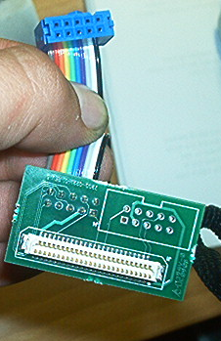
The MC100CA ribbon cable that attaches to male DF-9 connectors

Using the MC100CA ribbon, given our mica2 kit limitation, we cannot interface a sensor board to the radio board. We may eliminate this limitation by purchasing a rather larger or longer male-to-female DF-9 interface.

Hardware Limitations
The Khepera Serial Communications Mode
The miniature robot generally works in two modes: Serial Communication Mode and Program Execution Mode, in various baud rates for the corresponding UART communications. When running in Serial Communications mode, the robot “listens” to Line-Feed terminated strings on its UART Rx line that represent a small protocol of commands, such as C,2000,1500 (tells the robot to move its motors, in order for the encoders to reach 2000 and 1500 values respectively). It would be a very suitable mode for our application. We have considered an external battery (as well as additional circuitry) on top of the robot, in order to prolong the Khepera battery life span throughout the process. It appeared from tests, that most probably the robot would be strained during motion due to the heavy load of the battery.
We eventually used serial communications mode just to test the serial link between the mote and the robot. When finished, the Khepera will be capable od “listening” and “obeying” the UART in either program execution mode, or serial communications mode without baring an extra battery load.

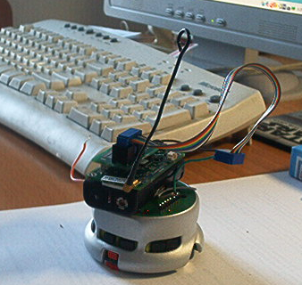
The Khepera carrying its little friend.

Documentation Limitations
For some mysterious reason, the MPC100CA kit comes with no pin-out schematics at all. We literally had to guess what pin connects to what. Here’s what we found out: When looking at the ribbon cable pin connector, Gnd, TxD and RxD lines are as shown in the following figure:
Gnd Reference Pin
The mote TxD pin
Mote RxD

The ribbon cable pin-out connections (blue connector)

Serial and RadioCommunications NesC code

The TOS_Msg structure limitation
Most of NesC interfaces are built in a manner such as to facilitate data exchange either through the radio or the UART by wrapping raw in to a data structure called TOS_Msg:

typedef struct TOS_Msg
{
/* The following fields are transmitted/received on the radio. */
uint16_t addr;
uint8_t type;
uint8_t group;
uint8_t length;
int8_t data[TOSH_DATA_LENGTH];
uint16_t crc;

/* following fields are not transmitted */
uint16_t strength;
uint8_t ack;
uint16_t time;
uint8_t sendSecurityMode;
uint8_t receiveSecurityMode;
} TOS_Msg;

One of the few ways (maybe the only. Haven’t checked out the ByteComm) to program the mote to send/receive raw bytes through UART, is to use the HPLUART interfaced, wired to HPLUARTC component:

interface HPLUART {

async command result_t init();

async command result_t stop();

async command result_t put(uint8_t data);

async event result_t get(uint8_t data);

async event result_t putDone();
}

HPLUARTC component works fairly simple. It puts out 1 byte at a time over the UART, pending a “putDone” interrupt. In quite the same way, we implement the interrupt handler for the corresponding “get” interrupt, obviously triggered when a character has arrived. Our applications, LiarBase and LiarClient use the HPLUART interface, wired to HPLUARTC.
When releasing a newer version of the data link application, we shall use a new interface called “UartRawSendMsg” (and its corresponding component, UartRawComm) to implement raw line feed-terminated strings transmission and reception.

The LiarBase and LiarClient NesC programs
We ‘ve set up a mote sitting on an MIB510 programming board, connected to the PCs COM1, running LiarBase. LiarBase simply receives raw bytes through the serial port, until a Line Feed character or a chr(13) character has been detected. It then simply wraps the raw string into a TOS_Msg and broadcasts it into the air.
Quite in a similar way, another mote that sits on the Khepera having its TxD line directly hooked to the robot’s RxD pin, running the LiarClient application. LiarClient indiscreetly handles messages that arrive through the air. It unwraps the raw string contained in field “data” of the TOS_Msg structure; it then transmits byte-to-byte over the UART (where the Khepera is supposed to be listening).
Both LiarBase and LiarClient are preliminary testing code rather than a final application. We shall implement an entire message transmission protocol (KNET_Msg structures) to facilitate a peer2peer network of motes that interact with “partners” through the UART.

Notes – The Usual “what did I do wrong” problem
Set your terminal to the following settings in order to start typing commands for your remote Khepera:

Port: COM1
Baud Rate: 57600
Stop Bits: 2
Handshaking: Xon/Xoff

If you are a fast typist, take it easy! The string transmission to the Khepera is a process synchronized by a timer (until now. This will change with the UartRawPacket component). It’ll take a while until you see the yellow light stop toggling its state; plus, the Khepera needs to take its time to respond after a move command. The LiarClient will NOT store consecutive commands when the arrival time of one string overlaps the processing time of the other. It will mess up a global variable representing the string to be transmitted to the robot.

Integrating Final Modifications and Upgrades

The Buffering problem in Robot-Mote message exchange
The Khepera utilizes 0-5V TTL signals out its RS-232 TxD line. The 5V peaks would probably damage the Mote’s UART or, in the best case, cause resets and various side effects while application execution in the mote.
To avoid hardware damages, we’ve constructed a simple buffer to lower voltage levels from 5V to 3V once a logical “1” is conveyed from the robot TxD line to mote RxD line. Figure below shows the buffer circuit, using a low voltage TLC272CP op-amp as a voltage selector:

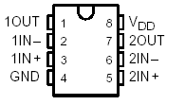
10KΩ
10KΩ
3.1V (Mote battery)
Khepera TxD line
Mote RxD line
TLC272CP

NesC Software Components and relative Interfaces
In order to provide an application independent module to accommodate raw data serial communications, we have implemented a NesC component called “UartRawPacket”, and the relative interfaces called “UartRawSendMsg” and “UartRawReceiveMsg” for data transmission and reception respectively over the mote’s UART. UartRawSendMsg and UartRawReceiveMsg, involve line feed or chr(13)-terminated strings; they include the following commands and events:

interface UartRawReceiveMsg
{

event char* receive(char* m);

}

interface UartRawSendMsg
{

command result_t send(char* msg);

event result_t sendDone(char* msg, result_t success);

}

The Transceiver application
The NesC application that implements the radio link that delivers raw strings from/to the robot using two motes on each side is called “Transceiver”. The transceiver receives raw strings from the UART, “wraps” the data into a TOS_Msg structure; the structure is then added to a radio transmission queue. Quite the same is done when a radio message arrives. The Transceiver “unwraps” the string and adds it to a UART transmission queue. Messages from the UART that exceed the TOS_Msg payload length(29 bytes) are “broken” into two or more radio messages, pending transmission in the radio queue.

